My Story: Introductions
Mike Long
Every rising tide eventually ebbs. Champions usually fade well before their accomplishments are appreciated, most of all by themselves. In time, the passionate work and hours of toil take their toll, and defining moments begin to tell a different tale than they once did. So I stand, after a full year out of the glow of Top 8's and the scandalous events that seem to have defined my career as much as have my wins, and I wonder now if my run in Magic has ended.
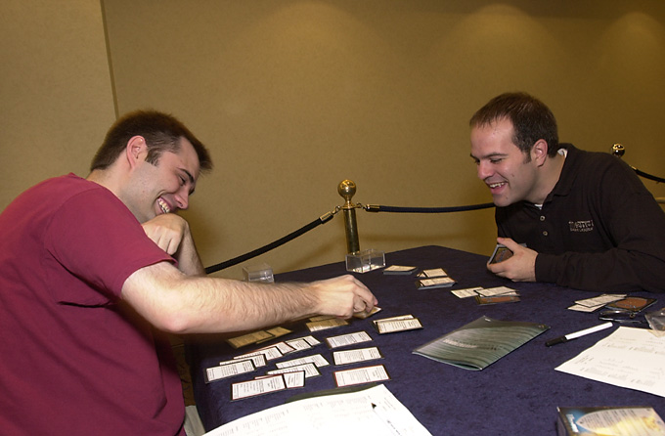
Not much more than a year ago, I felt poised to recover the mantle of the game's top prize earner. The mysterious war that I had waged with the rest of the Magic world once again seemed to swing in my favor. I had just made the Top 8 of the U.S. Nationals for the fourth time in six years, and I was in the semifinals of the first Master's Series draft tournament. To many, it appeared as though I would win both events and come within a few thousand dollars of Jon Finkel's perch as the game's top prize winner. The scandalous defeat that ensued, along with a close miss at that year's World Championships, instead seemed to signal the beginning of the end of my career.
I think that there are two reasons that reading my story is worthwhile. The first thing is that I've played for so long at a pretty good level. I've probably been qualified for as many events as anyone, and as the faces of the game have changed, I've usually kept up the pace. At the very least, I have some perspective to show for my years of play.
The second thing is, of course, the infamy. My early battle to gain the respect of my peers and reach success within the game resulted in a strange combination of fame and angry outrage from those whose esteem I sought. Worthy opponents became enemies, blaring out warnings about my vicious nature in a seemingly endless series of poisonous postings on the Dojo, a web site whose fame seemed to rise with my notoriety.
That is not to say that this infamy was by any means unearned. The furious passion I poured into my game in the early years was understandably misinterpreted by many as utter lawlessness. It seemed that almost every tournament I played in featured pitched battles with judges, waged publicly over silly points, heated arguments with my opponents, and more than anyone's share of taunting and gamesmanship.
Though I have remained largely silent in terms of postings and articles during for the last several years, I now feel the need to share my story with the growing world of Magic. Whether that is because I hope the new players of the game will know me better than current ones know Mark Justice and Bertrande Lestree, because I seek redemption and understanding for my past trespasses, or because I hope to chronicle a mighty comeback is of no consequence - my story will be the same. This is how I came to be a recognized Magic player. This is how I survived the infamy that my aggressive style invited. And this is how the year of a Magic player/person plays out.
As a new Pro Tour season begins, so too I begin what will either by my come-back or the final chapter of my Magic career.
Stay tuned to Sideboard for the next chapter in Mike's story.

